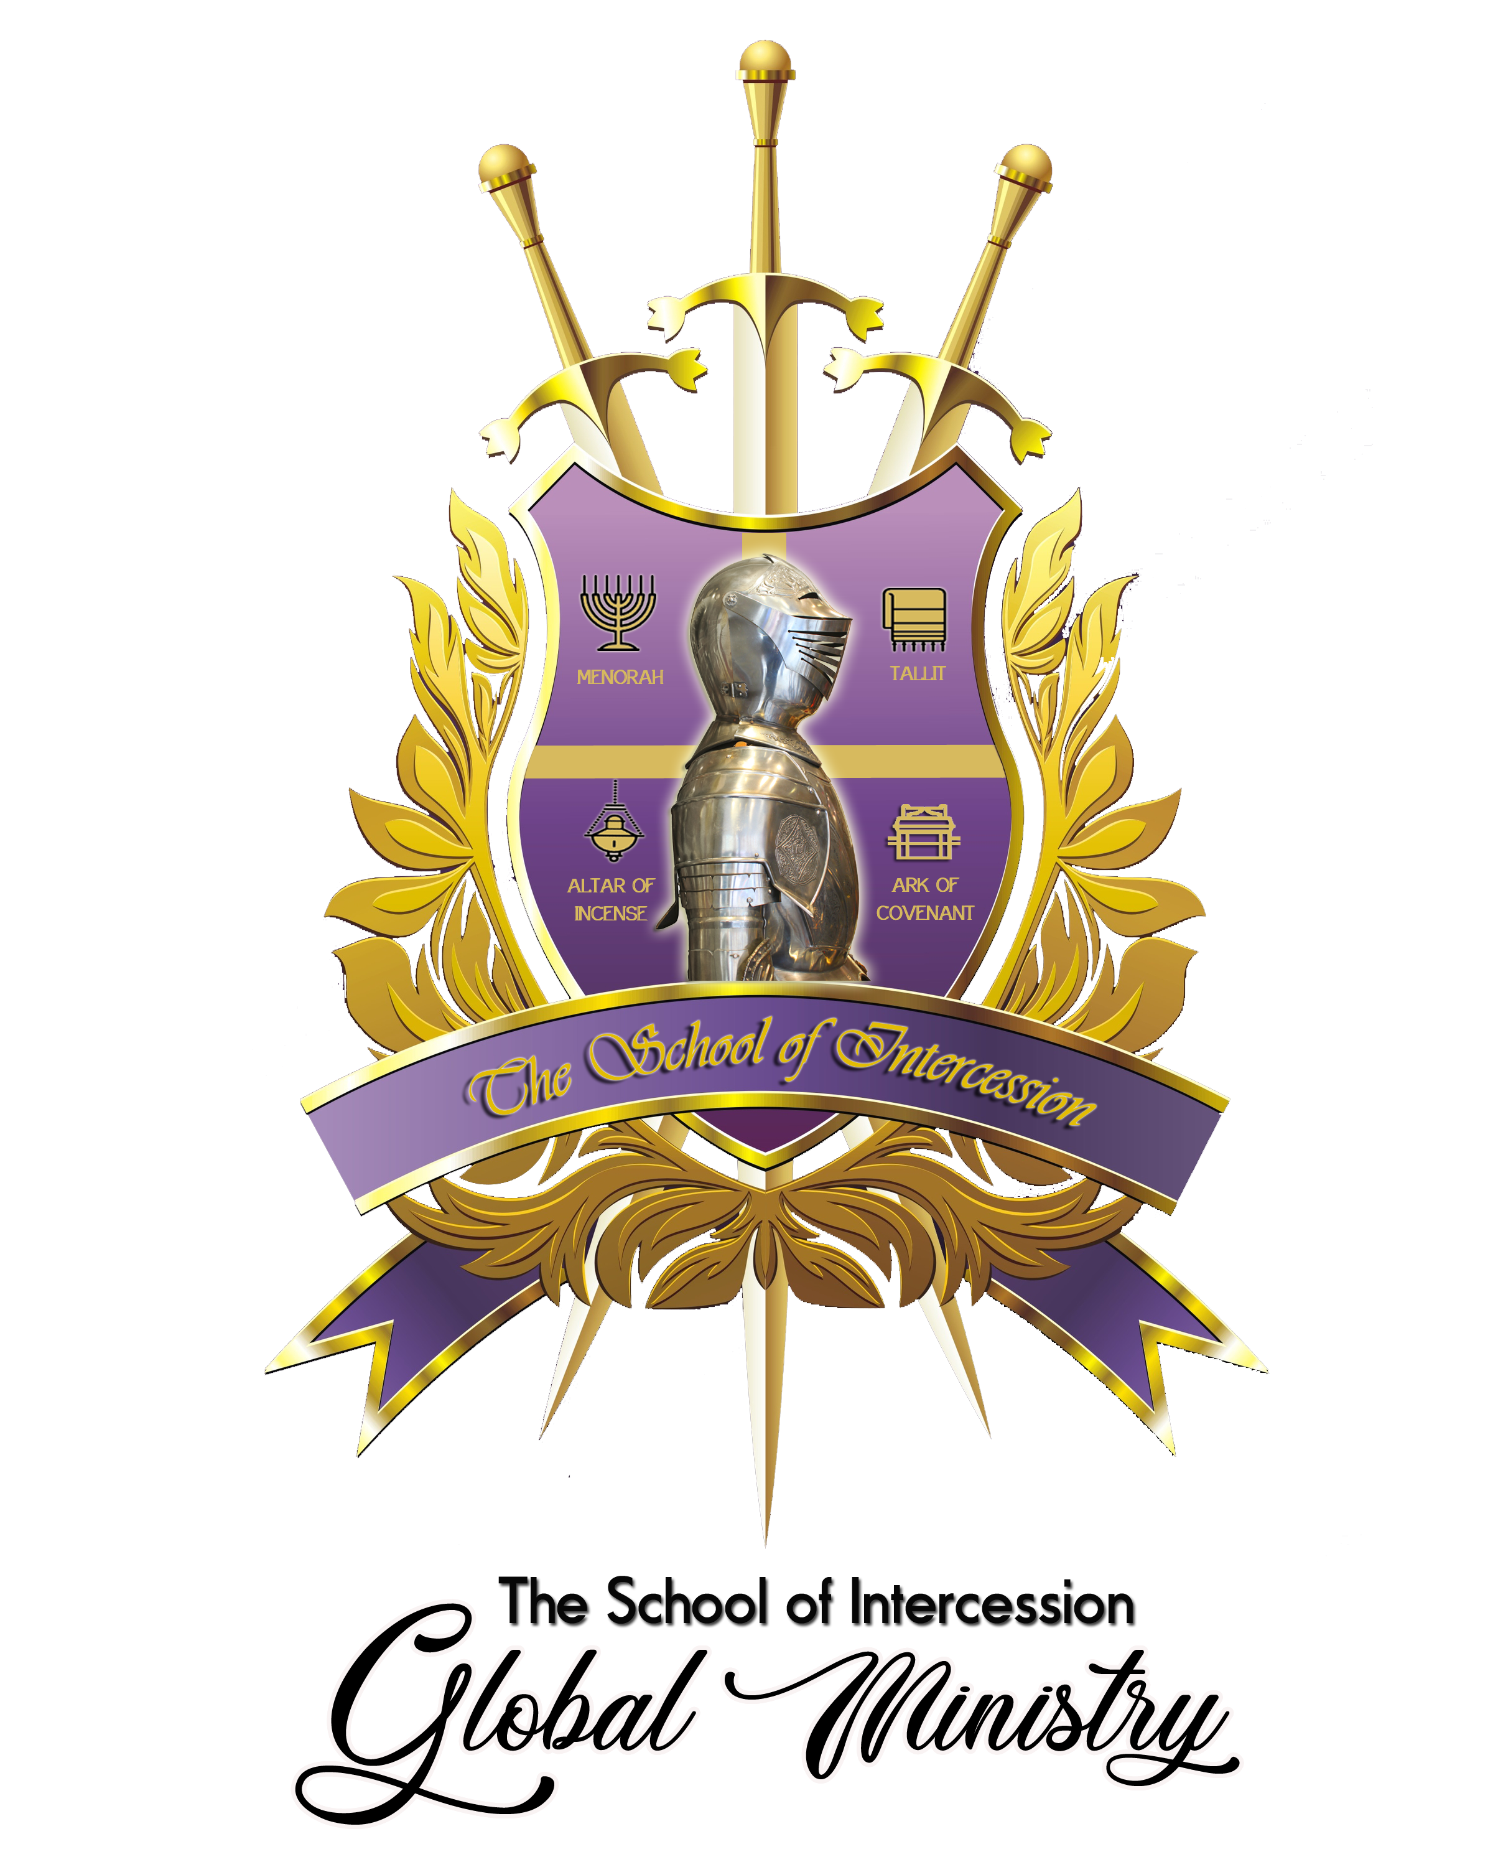

CHECKLIST FOR BEGINNER'S - ADVANCED COURSES 20-23

Name: ____________________________ SOI ID#: ___________________ Date: ________
President, Apostle Terence Davis | VP, Prophetess Rasheda Davis

Freshman Courses (FALL):
3 ______
3 ______
3 ______
3 ______
3 ______
3 ______
3 ______
3 ______

00 INTRO – The Assignment of the Holy Spirit
01 HS, How to hear God’s voice clearly? (Clean Heart Principle included)
02 HS, Hindrances that keep you from hearing God’s voice?
03 GIFTS, The Gifts of the Holy Spirit

04 GIFTS, The Power of Praying in Unknown Tongues (Prayers Led by the Spirit)
05 TAB, The Tabernacle - The Key of Worship! The Pattern of Prayer
06 KING, The Kingdom is within you?
07 KING, Reshaped and Conformed with a Kingdom MINDSET / Culture

Total 24

Sophomore Courses (SPRING):
08 INTER, The Key of Intercession/Roles of Intercessors
09 INTER, Growing in Intercession: Differ types of prayers
10 WAR/INTER, Revival Intercession
3 ______
3 ______
3 ______
3 ______
3 ______
3 ______
3 ______
3 ______
3 ______
3 ______

11 WAR, Spiritual Warfare- Round 1 | Basics of War
12 WAR, Round 2: Cast out demons & Self-deliverance
13 WAR, Round 3: Battle in the heavenlies to overthrow strongholds
14 WAR, Round 4: How to tear down the gates of hell?
15 WAR, Round 4: Prayers that produces healings & miracles
16 WAR, Round 5: Prayers to endure | To break soul ties & mind control
17 WAR, Round 6: War against Jebezel, Ahab and territorial spirits

Total 30

Junior Courses (SUMMER):
3 ______
3 ______
3 ______
3 ______
3 ______
1 ______
18 LEAD, Leadership Teaching: 5-Fold Ministry (Apostles, Prophets, etc.)
19 LEAD, Leadership Teaching: Corporate Prayer (City/Region/Nation)
20 LEAD, Leadership Teaching: Ranks of Authority
21 LEAD, Leadership Teaching: Governmental Intercession
22 LEAD, Leadership Training: Apostolic & Prophetic (Advancements)
23 LEAD, Leadership: Leadership Classes & Mentor-Internship Assignment
Round Tables Conversations, Luncheon/Gatherings, Leadership Mentorship
24 LEAD, Leadership: Conference (How to flow in the Apostolic)
25 Lead, Leadership: How to build intercessory and deliverance teams TBA

Total 16

Senior Courses (Optional):
3 ______
3 ______
3 ______
3 ______
3 ______
3 ______
1 ______
19 PROPHETIC, The Authority of the Clean Heart Prophet
20 PROPHETIC, Managing the Call with Godly Wisdom
21 PROPHETIC, Overcoming Rejection as a Prophet
22 PROPHETIC, Eagle-Eye Training (Developing Prophetic Lens/Seer)

23 PROPHETIC, Understanding the Prophet's DNA – The Office of the Prophet
24 PROPHETIC, I AM A PROPHET (Understanding your prophetic flow/style)
25 PROPHETIC, Prophetic Senses/ Impartation/Activation

Total 31
There will be other classes added at a later time!
Check SOI website (monthly) for updates @ www.soiglobalministries.org

Conferences, Seminars, Workshops and/or Virtual Services:
SOI Deliverance - Training in deliverance along with “Deliverance Services”
SOI Prayer Boot Camp Training & Equipping (Establishing Special Forces Teams/Strategists)
Prophetic Prayer Services along with prophetic training
The Bride of Christ Training – Be Rapture ready daily!
Marriage & Singles Retreats/Conferences
Youth & Young Adults Prophetic Prayer & Worship Training Nights
Young Adults Bible Study / Training Evangelism Young Adults Prophetic Prayer Team
Apostolic Strategist Meetings for the City wide/State/Region/Nations –Corporate Oneness among the Body of Christ

